**Learner Assignment Submission Format**

**Learner Details**

* **Name:Nikhil k**
* **Enrollment Number: su625mr004**
* **Batch / Class: Mern Stack**
* **Assignment: React Basics Day 1**
* **Date of Submission:**

**Problem Solving Activity 1.1**

**1. Program Statement**

Design a **personal resume webpage** using HTML that includes:

* Personal details (name, contact info, GitHub, email)
* Objective statement
* Educational qualifications (in tabular format)
* Technical skills (listed as bullet points)
* Project experience (with descriptions and technologies used)

**2. Algorithm**

• Create a standard HTML document structure with <html>, <head>, and <body>.

• Use <center> and heading tags (<h1>, <h2>, etc.) for name and contact details.

• Use paragraphs <p> to describe objectives.

• Display educational qualifications using an HTML <table> with proper rows and columns.

• List skills using unordered lists (<ul> with <li>).

• Describe projects using <ul> and <li> with <strong> and <em> for formatting.

**3. Pseudocode**

START

CREATE HTML document

INSIDE body:

DISPLAY name, address, contact, and email centered

DISPLAY "Objective" with bullet points or paragraphs

CREATE table for education details with Degree, Institution, Year, Percentage

DISPLAY technical skills as a bulleted list

DISPLAY projects as a list with description and technologies used

END

**4. Program Code**

<!DOCTYPE html>

<html lang="en">

<head>

    <meta charset="UTF-8">

    <meta name="viewport" content="width=device-width, initial-scale=1.0">

    <title>Document</title>

</head>

<body>

    <center><h1>NIKHIL K</h1></center>

    <center><h4>Yelachenahalli, Banglore 560078</h4></center>

    <center><a href="tel:+919380085115">+91-9380085115</a></center>

    <center><a href="https://github.com/Nik5codes">https://github.com/Nik5codes</a></center>

    <center><a href="mailto:nikhilkunjathaya5@gmail.com">Email:nikhilkunjathaya5@gmail.com</a></center>

    <u><h2>Objective</h2></u>

    <p>To work in a challenging environment that enhances my skills and knowledge.</p>

    <p>To work in a company that provides me with the opportunity to improve my skills and knowledge to grow along with the organization.</p>

    <hr>

    <u><h2>Education qualification</h2></u>

    <table border="1" cellpadding="10" cellspacing="0" Width="100%">

        <tr>

            <th>Degree</th>

            <th>Institution</th>

            <th>Year of Passing</th>

            <th>Percentage</th>

        </tr>

        <tr>

            <td>MCA</td>

            <td>Dayananda sagar college of Engineering</td>

            <td>2025</td>

            <td>8.17CGPA</td>

        </tr>

        <tr>

            <td>Bsc Electronics</td>

            <td>Vivekananda degree college</td>

            <td>2019</td>

            <td>7.8CGPA</td>

        </tr>

        <tr>

            <td>PCMCs</td>

            <td>Ambika P U college</td>

            <td>2017</td>

            <td>67.83%</td>

        </tr>

    </table>

    <hr>

    <u><h2>Skills</h2></u>

    <ul>

        <li>C</li>

        <li>C++</li>

        <li>Python</li>

        <li>Java</li>

        <li>HTML, CSS</li>

        <li>SQL, PL/SQL</li>

        <li>Git</li>

        <li>React</li>

    </ul>

    <hr>

    <u><h2>Projects</h2></u>

    <ul>

    <li>

        <strong>Intern, Gonagoor Technology Solutions</strong> (Nov 2024 – Jan 2025)<br>

        Contributed to mobile app development using React Native, Firebase, and Python. Worked on feature implementation, bug fixes, and performance improvements in an Agile environment.<br>

        <em>Technologies used:</em> React Native, Firebase, Python

    </li>

    <li>

        <strong>NMMS Initiative & Grantha Mithra Program</strong><br>

        Supported NMMS exam prep by enhancing an educational website and mentoring rural students in academics and personal development through library programs.<br>

        <em>Technologies used:</em> HTML, CSS, JavaScript

    </li>

    </ul>

</body>

</html>

**5. Test Cases**

| **What to Check** | **Expected Result** |
| --- | --- |
| Name, contact, and links centered | Properly aligned in the center |
| Table format | Education qualifications appear neatly in a grid |
| Bullet list for skills | All skills displayed in bullets |
| Project descriptions | Each project has a clear title, date, and tech stack |
| Resume loads in browser without errors | Yes |

**6. Screenshots of Output**

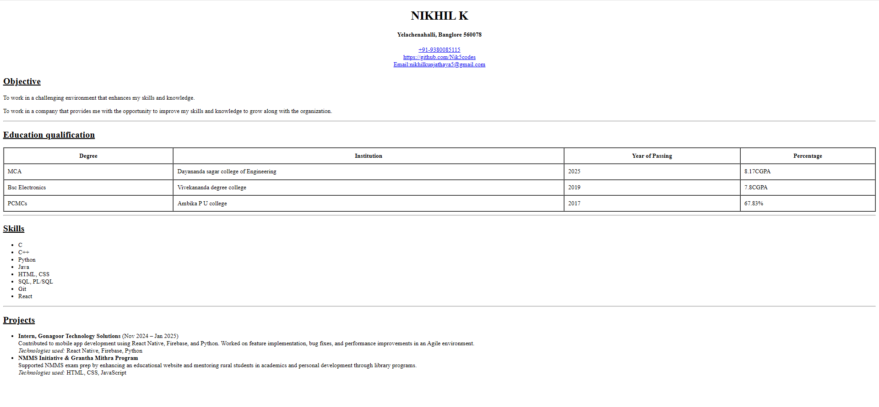

**7. Observation / Reflection**

• I faced a small challenge in aligning content and keeping the layout clean using only HTML.

• I learned how to use basic HTML tags like <table>, <ul>, and <h1> to structure a resume.

• Next time, I would use CSS instead of <center> for better styling and responsiveness.

**Problem Solving Activity 1.2**

**Follow the same Structure as problem Solving Activity 1.1.**